BI1I – FINAL EXAM (100 pts)
Winter Term 2026
Released: Friday, March 11, 2026
Due: Thursday, Wednesday 18, 2026 (midnight)

This is a closed book exam. You can NOT use any notes or books or internet or outside resources. You must NOT use ChatGPT or other AI platforms to write your answers, zero tolerance. (Grammatical mistakes are okay as long as we can understand what you mean; plagiarism or AI-write is not okay!)

The exam should take approximately 3 hrs from start to finish. Write it continuously in one session, not broken up with coffee breaks, conversations, etc. If you find you need a little more time, you are welcome to take up to an hour longer – just indicate where you were at the 3-hr mark and write at the end how long it took you to finish.

Problem 1. T cell – B cell interactions and distinctions (46 pts)

As discussed in class, transgenic mouse lines are commonly used in immunology research to perform experiments in a system that has T cells with a known TCR. As a refresher – these transgenic (tg) mouse lines are engineered so that the T cells in the mouse faithfully express the same TCR against a specific antigen of the researcher’s choice.

The OT-I and OT-II tg mice strains have been well used and well-studied for these purposes. OT-I mice and OT-II mice each contain T cells that express a unique TCR to recognize ovalbumin, or OVA, which is an egg white protein (so T cells from OT-I mice express a specific TCR that recognizes OVA, while T cells from OT-II mice express another TCR that also recognizes OVA).

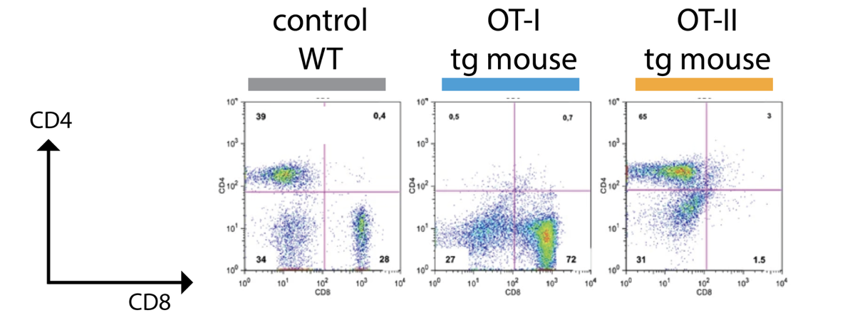
You are curious to see if there are any differences between T cells harvested from OT-I mice versus from OT-II mice, so you first look at T cells in the periphery from each mouse (compared to a WT control mouse) with flow cytometry. You get the following results:

a. Compare the flow cytometry plots from WT mice versus OT-I mice and OT-II mice. What kind of T cells are found in OT-I mice? How about in OT-II mice? Make sure to explain how you came to these conclusions from the data provided. 4 pts

b. Building off your conclusions from above, would you expect antigen presentation to look different in OT-I mice versus OT-II mice; would you expect different cell types to be involved in activating T cells from OT-I mice versus OT-II? If yes, how so? Explain your reasoning and make sure to demonstrate knowledge of T cell activation by antigen presentation. 4 pts

c. Taking this one step farther, would you expect certain immunological threats to be better detected in OT-I mice versus OT-II mice? In your explanation, make sure to demonstrate understanding of the biological mechanisms driving your answer. 4 pts

d. Would you expect any difference in effector programs between T cells in OT-I mice and OT-II mice? Why or why not? Consider their potential contributions to B cell help, macrophage activation, and direct target killing. Explain your answers. 4 pts

Reminded of B cells, you choose an OT-I mice and take out a lymph node to probe the B and T cells.
e. In the lymph node, does T cell activation look different than B cell activation? Is there any interaction between T cells and B cells themselves? Make sure to include specific cell types and cell surface receptors/ligands in your explanation. 4 pts

f. When you look at the B cells from OT-I mice and compare them with T cells from the same OT-I mice, you find that B cells have much higher affinity for OVA than the T cells. Why is this? Be as specific as you can in your explanation (think about molecular mechanisms and B cell activation, as touched on in the previous problem). 4 pts
g. You want to search for any T cells you might have missed that have high affinity to OVA. You end up looking in the thymus and find in the thymic medulla a few T cells with extremely high reactivity not to OVA but to certain antigens that resemble self-peptides. Do you expect these T cells to ever enter lymph nodes? Is there any circumstance in which they would leave the thymus? 4 pts

h. You want to see how OT-I and OT-II response changes after mice have been immunized with OVA more than once. Upon the second exposure to OVA, you see that both OT-I and OT-II mice have a much faster immune response. Why was the first response so much slower than the second response? 4 pts
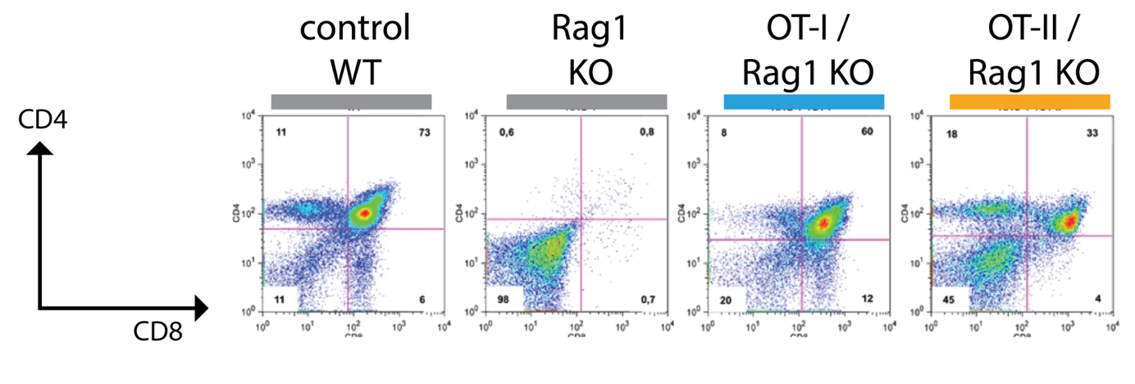
You next recall from Bi1i that Rag1 is important for V(D)J recombination in T cell development. You wonder if OT-I mice and OT-II mice need Rag1 expression to produce their T cells. You create a mouse line with a Rag1 knockout and cross these Rag ^{-/-} (Rag knockout) mice with the OT-I and OT-II lines. This time, you analyze T cells from the thymus and get the following flow cytometry plots:

i. Interpret the results from the flow cytometry plots for the OT-I/ Rag ^{-/-} and OT-II/ Rag ^{-/-} thymic T cells: do the T cells from OT-I and OT-II require Rag1 expression? Make sure to include a comparison to WT controls and to Rag1 knockout data in your explanation; also incorporate your knowledge of the biology to explain why the conclusion makes sense. 6 pts
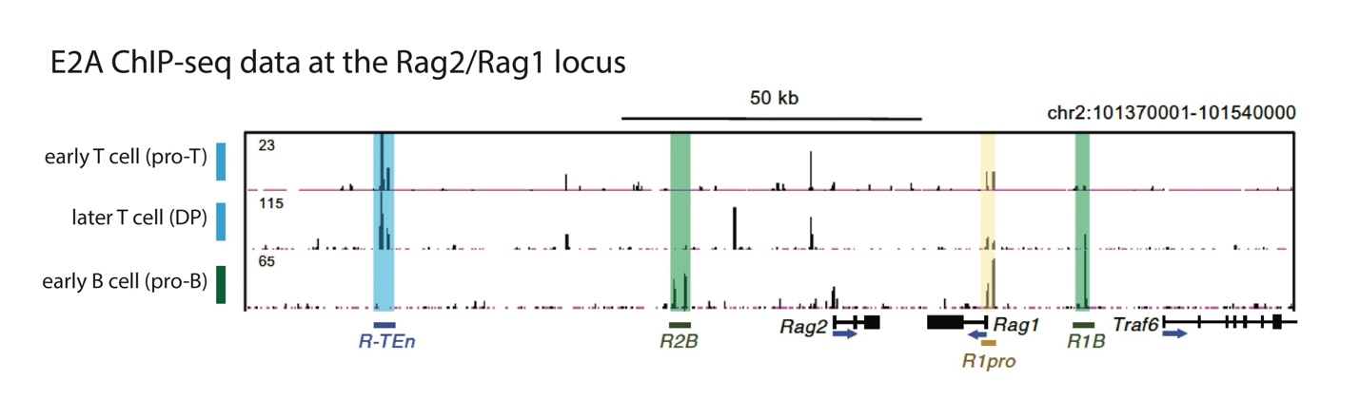
Finally, you wonder how Rag1 expression is even properly controlled in the first place. A quick Google search tells you that a transcription factor called E2A is supposed to be important for activating Rag1 in developing T cells and developing B cells. However, you don’t want to blindly trust Google AI, so you find a dataset from an E2A-specific ChIP-seq experiment on developing T cells and B cells and look at the results for the Rag2/Rag1 locus shown below:

j. The blue R-Ten and green R2B/R1B highlighted regions represent enhancers for Rag1. “Early” and “later” T cells are different immature populations within the thymus. Based on the ChIP-seq profiles shown above, what is the relationship between E2A and Rag1? Include a description of enhancers and make sure to describe how you interpreted the data in your explanation (demonstrate understanding of what ChIPseq data reveals). 4 pts

k. If you have a well-funded lab and you can make transgenic and knockout mice at will, what experiment would you do to determine the functional impacts of the R-TEn and R2B sites? What would you expect to see in the T and B cells of the resulting animals? 4 pts

Problem 2. You’ve explored TCR signaling, but how about signaling pathways in the innate immune system? (30 pts)
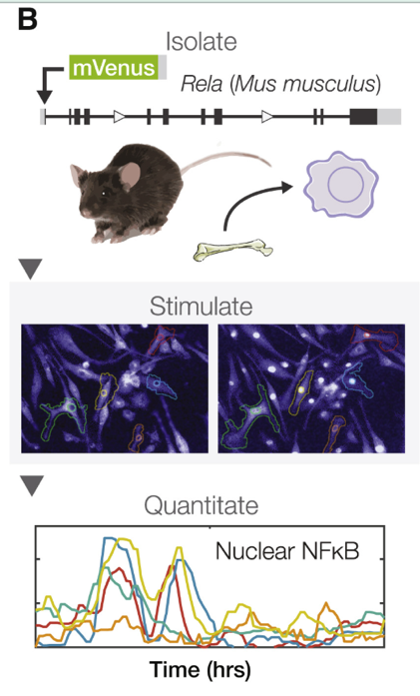
As you may recall, macrophages are an important member of the innate immune system as they phagocytose extracellular material, can participate in antigen presentation, and can respond to cytokine signaling cues (you might recall the polarizations - M1: pro-inflammatory M2: anti-inflammatory). The transcription factor NFκB is downstream many signaling pathways that the macrophage relies on to perform these cellular functions, so a big question emerges: how does the macrophage interpret different environmental signals while utilizing the same downstream transcription factor (TF)?

Of course, many other TFs are involved, but this problem will focus on the specific role of NFκB. Researchers wanted to know if NFκB activity changes based on the stimuli that the macrophage encounters.

To test this, researchers first made transgenic mouse models that expressed NFκB (specifically the NFκB family member RelA) with a fluorescent reporter protein (mVenus). When they grew macrophages in vivo using progenitor cells derived from this transgenic mouse, they could track NFκB movement in real time by using a fluorescent microscope to following the fluorescent signal produced by mVenus in real time. The schematic of this experiment is shown in panel B to the right.

a. Using this system, researchers wanted to track NFκB expression in the nucleus, hence the graphical traces shown at the bottom of the schematic above. Why was it important to them to track NFκB in the nucleus; in other words, what does the presence of nuclear NFκB in macrophages indicate? 4 pts

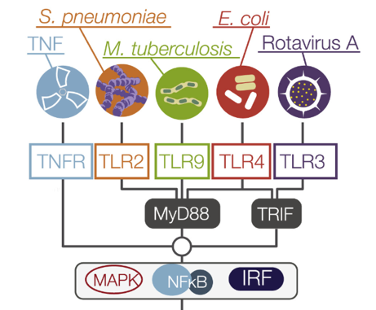
Next, researchers wanted to see how NFκB activity changes when macrophages in vivo are exposed to different stimuli. They chose 5 different stimuli: 1 cytokine (TNF) and 4 pathogen-associated molecular patterns, or PAMPs, derived from 4 different bacterial/viral strains. A description of these 5 different stimuli and the subsequent cell receptors (boxes) and intracellular signaling domains is shown to the left, where MAPK, NFκB and IRF are the downstream transcription factor targets.

b. Elaborate on how cytokines and PAMPs are involved in our immune system; in other words, when are cytokines used in the immune system? And when are PAMPs relevant in the immune system? Would you expect macrophages to respond differently to cytokines and PAMPs? Try to include different concepts you have learned in Bi1i in your answer. 6 pts

c. You notice in the diagram that there are multiple TLRs that correspond to each PAMP. Why do you think the authors chose to analyze 4 TLR pathways rather than just 1 TLR? In the face of highly evolving pathogens, how do these TLRs contribute to the host’s immunological protection? 4 pts

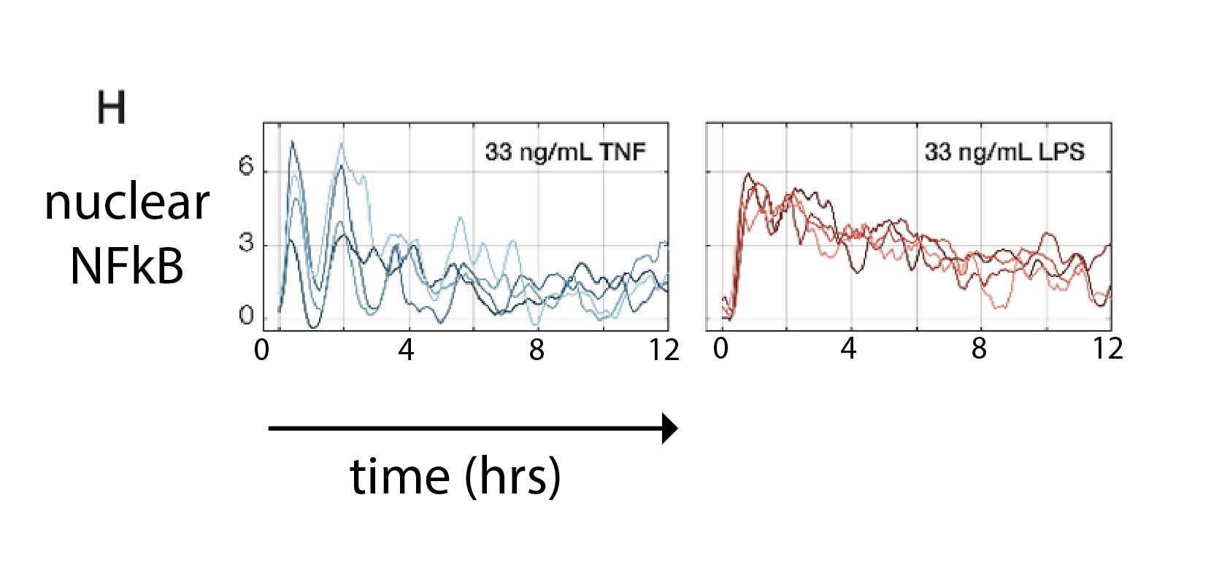
Zooming in on the results for TNF (blue) and LPS (red), derived from E. coli, the researchers tracked fluorescent signals for nuclear NFκB over 12 hours of observation of stimulated macrophages, shown in panel H below. Researchers used specific dosages of TNF and LPS (33ng/mL). The different colors within each left/right plot represent different representative traces of single cell’s nuclear NFκB over time.

Interestingly, the researchers concluded that cytokines produced “oscillatory” signaling while PAMPs produce “non-oscillatory” signaling.

d. Interpret the data presented in panel H in your own words; what do the graphs indicate about NFkB behavior in the macrophages? Would you consider NFκB activity to be transient or long-lasting? 4 pts

e. If NFkB activity was considered “lineage-defining,” what changes might you expect NFkB to cause within the cell? How might you test/measure this? 4 pts

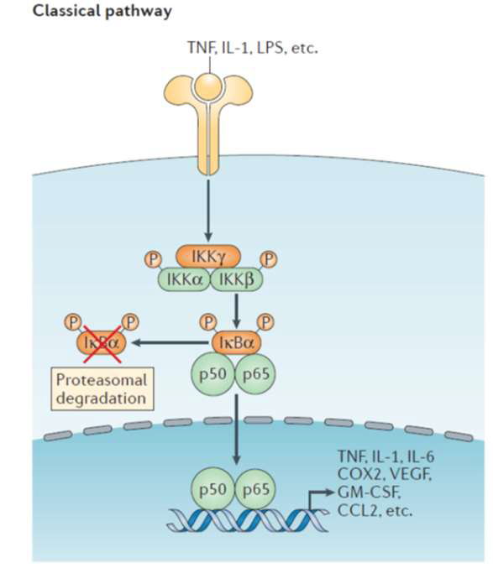
To determine why there seems to be different NFκB signaling patterns caused by TNF vs. LPS, researchers looked more closely at the distinct signaling pathways that involve TNF and LPS (which binds to TLR4). More specifically, researchers wanted to understand what molecular interactions cause this differential activity.

Let’s look at the NFκB signaling pathway a bit more closely (refer to the left diagram). NFκB actually already exists in the cytoplasm (shown as the p50/p65 complex) but is sequestered by an inhibitor protein (IκBα - we will call it “IKB”) in the cytoplasm, which prevents NFκB from entering the nucleus. Upon external signaling through a cell surface receptor, a kinase protein complex (collectively called IκBα kinase = IKK) is activated to mark the inhibitor protein IKB for degradation.

d. One of the most interesting features of the NFκB response system is that its own inhibitor, IKB, is synthesized under positive control of NFκB itself. Once made, it has the capacity to fish the NFκB out of the nucleus. What kinds of system behavior can result from this simple gene regulation circuit? What parameters are likely to determine which behaviors predominate? 4 pts

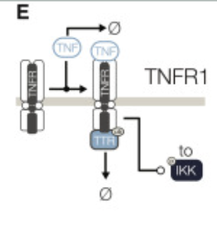
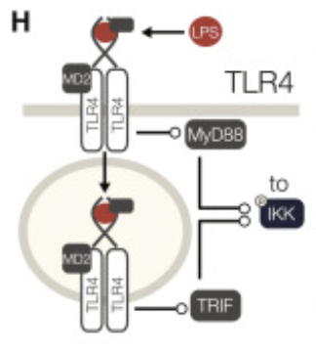
Consequently, the researchers attempted to mathematically model molecular circuits to determine how TNF/LPS signaling impacts IKK production in the cell. Their schematics are provided to the right for your enjoyment, but you do not need to reference them to answer the question.

e. Why did researchers focus on IKK downstream of TNF and LPS signaling? What other variables/questions would you have asked about the system to make a mathematical model? 4 pts

Problem 3. What to consider in therapeutic research? (24 pts)

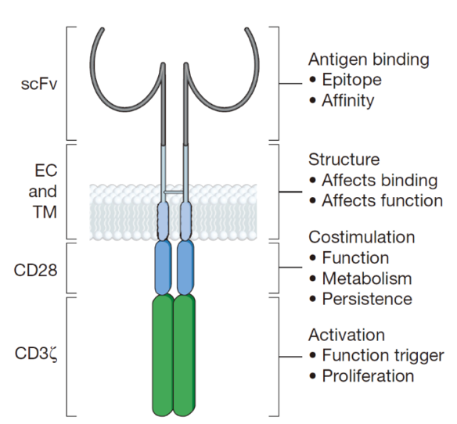
Extreme excitement has surrounded the idea of “CAR T cells”, pictured left; cells with Chimeric Antigen Receptors that use a modified immunoglobulin N-terminus (scFv part representing the arm of an antibody, with the variable antigen binding region at the end) linked to a scaffold of intracellular signal-related domains, derived from CD3ζ, CD28, and 4-1BB. These domains allow kinases, phosphatases, adaptors, and other signaling molecules to be recruited. The main way these cells are made is by taking mature T cells from a patient and transfecting them with CAR-coding DNA, then growing them in culture with a lot of IL-2 and occasional antigen stimulation. Sometimes, other modifications are made as well, to alter signaling and response properties of the cells.

You find CAR-T therapies fascinating, and want to consider how these are generated and what still needs to be done to make them more successful.

a. What are the advantages of using an artificial immunoglobulin as the antigen-binding part of the CAR (receptor), rather than the N-terminal parts of a normal TCR? Consider specificity and consider usefulness for multiple patients in the clinic. What does a normal TCR recognize? Suggest two reasons why this could be a handicap. 4 pts

You want your CAR-T cells to attack a tissue-resident tumor. You want to know if there are any properties of tissue-resident tumors that might inform your CAR-T cell design. After some literature research, something sticks out to you - studies have shown that CTLA-4 is found on the surface or within the cytoplasm of various human malignant tumor cells. High CTLA-4 expression is observed in a significant portion of tumors, including 80% of cervical cancers, 33.3% of small intestine cancers, and 33.3% of melanomas.

b. Why is high CTLA-4 expression on tumor cells potentially “bad” for your T cell-based therapy? 2 pts

Additionally, you find that researchers have developed anti-CTLA-4 therapies against cancer cells that overexpress CTLA-4. However, anti-CTLA-4 therapy commonly causes severe, high-grade immune-related adverse events in over 60–75% of patients, with a 24–43% risk of grade 3 or higher toxicity. Key side effects include severe inflammation of the inner lining of the colon, rashes, a rare inflammatory disease of the pituitary gland which causes headaches and visual changes (hypophysitis), and liver inflammation.

c. Why do you think anti-CTLA-4 therapies cause such drastic side effects? Make sure to describe in detail the specific cell types that might be impacted. 4 pts

This gives you more of a reason to believe that CAR-T therapy might offer a useful alternative strategy for eliminating tissue-resident tumors.

You consult a fellow classmate in Bi1i about your research thus far; however, your classmate reminds you that the immune system is not just dependent on T cells and B cells but also requires interaction with innate immune cells like dendritic cells (DCs). Your classmate worries that the dendritic cells could be incapacitated by CTLA-4 expressed on tumor cells as well, which would render CAR-T therapy ineffective.

d. Is this a valid concern? In other words, could CTLA-4 also impact DCs such that they become poor at antigen presentation? 2 pts

Your classmate additionally reminds you of “T cell exhaustion.” You refer back to the literature and indeed find that many conventional cytotoxic T cells near tissue-resident tumors become “exhausted.”

d. In thinking about the different activation requirements for effector vs. exhausted T cells, what other manipulations might you want to make to the CAR such that your CAR-T cells remain as “effectors” rather than becoming exhausted like the endogenous killer cells? Explain your answers and why the mechanisms that you are suggesting can be effective. 4 pts

e. Assume that the CAR T cells are made and are activated strongly by the target antigen. When you put them into a patient, what can go wrong? What kinds of problems could arise from antigen specificity, and what kinds could arise from something else? 4 pts

f. You have developed a very well-tested CAR that has exactly the specificity that you want against a deep tissue tumor. You make T cells with this CAR and infuse them into the patient. Unfortunately, you find the CAR-T cells in the blood and spleen, but not in the organ with the tumor. What factors might keep the T cell out of the tumor site? What might be missing and what might you test your CAR-T cells for as a result? 4 pt

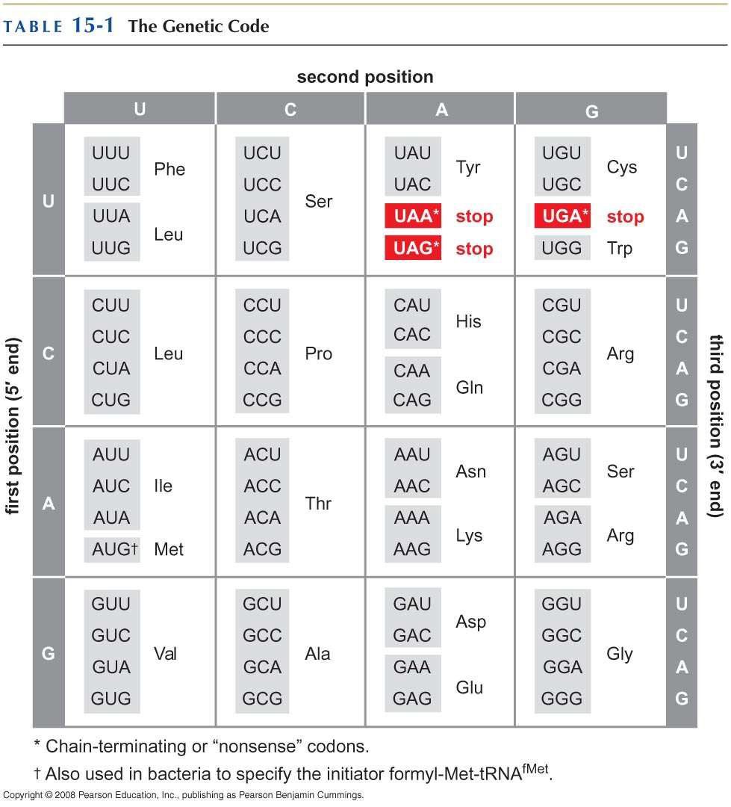

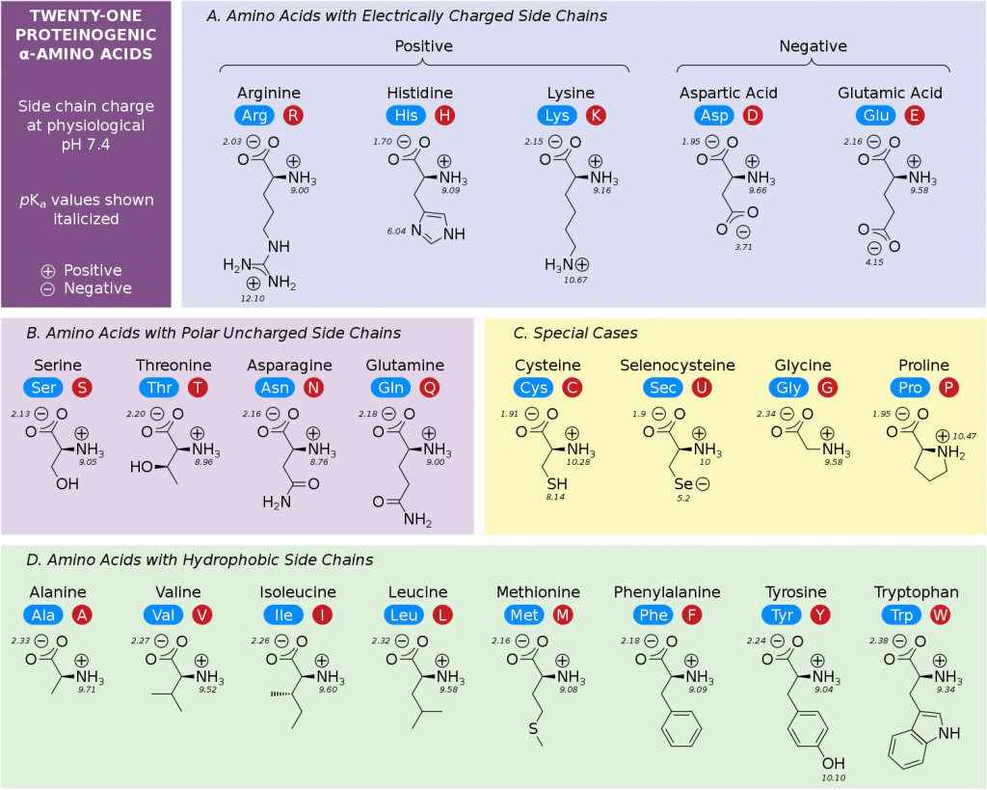

This is a beautiful schematic, except let’s point out that selenocysteine is NOT a separately encoded amino acid! Also, let’s explain what the little numbers are (pK’s - ionization pH’s)

** note: selenocysteine is NOT a separately encoded amino acid!!
** note: pKa = measure of a molecule’s acidity where low pKa indicates strong acidic properties while high pKa indicates weak a

